Assignment 2:

1. Paste the link to your github directory here

https://github.com/YarenTekdemir/se373.git

1. Design the following app in Figma

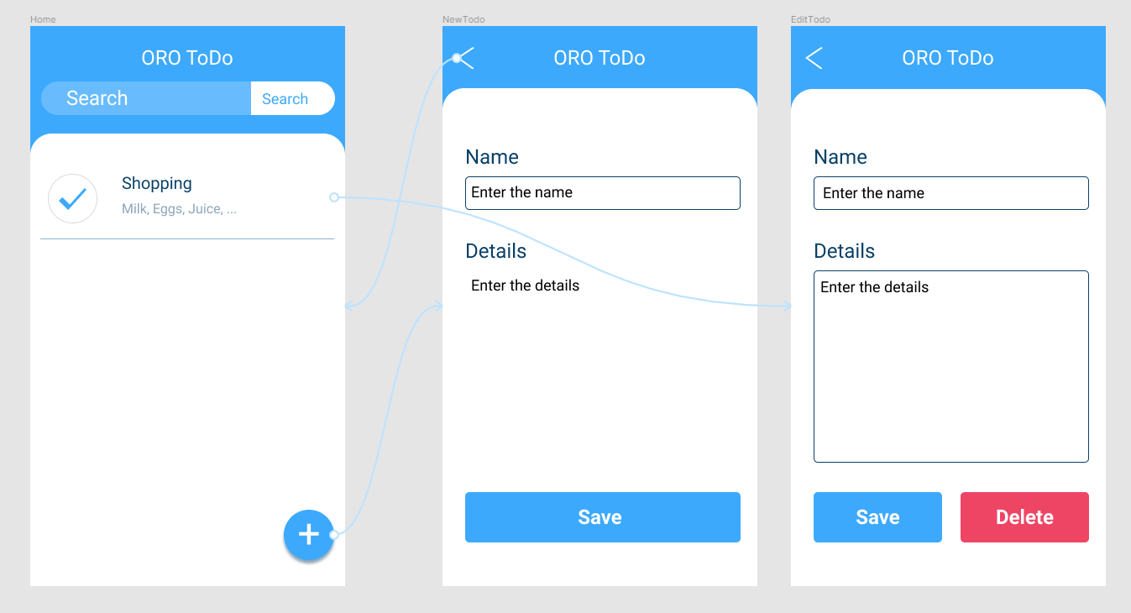

Give the app title the name your_initials ToDo

At the home page

* When to do item is clicked, it should open the edit page
* When the plus sign is clicked, it should open the new page

At the new todo page

* When the < button is clicked, it should go to Home page
* When the save button is clicked, it should go to home page

At the EditTodo page

* When the < button is clicked, it should go to Home page
* When the save button is clicked, it should go to Home page

1. Take a screen capture of each page and the links between pages, paste them in a word document, put it in your github directory you created for this course.

metin, ekran görüntüsü, diyagram, yazı tipi içeren bir resim

Açıklama otomatik olarak oluşturuldu

The class

Different objects goes to different pages.

diyagram, ekran görüntüsü, grafik, tasarım içeren bir resim

Açıklama otomatik olarak oluşturuldu